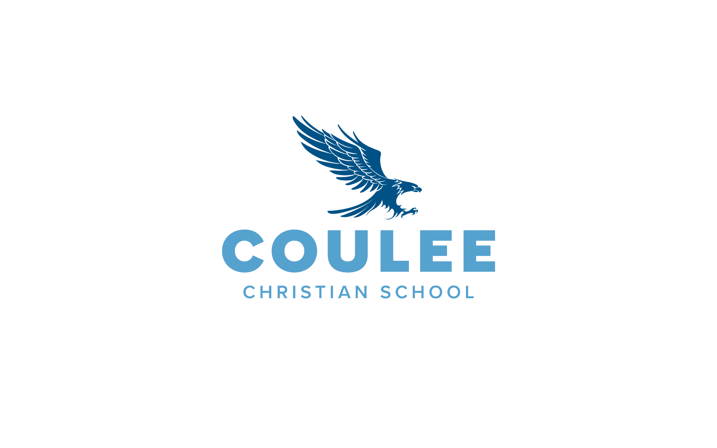

**POSITION:** Teacher **STATUS:** Exempt

**SUPERVISOR:** Principal  **DATE:** May 2025

**Job Summary:**

Provide instruction to meet the needs of all learners in the classroom. Create a safe, constructive, productive, and God-honoring environment that focuses on helping each student grow in all areas including socially, emotionally, academically and spiritually. Plan instruction that meets the needs of all students by differentiating instruction and following student accommodation plans. Embody and grow in all qualities identified in the Portrait of a Coulee Christian School Teacher.

**Required Spiritual Qualities**

It is expected that the Teacher will:

* Acknowledge Christ as Savior and seek to live as His disciple.
* Believe the Bible to be the inspired, the only infallible, authoritative, inerrant Word of God, our standard for faith and practice.
* Believe and actively support Coulee Christian School’s **Statement of Belief**.
* Demonstrate a desire for spiritual growth as evidenced by his or her prayer life, Bible study, and spiritual outreach to others.
* Be a **Christian role model** in attitude, speech, and actions toward others. This includes being committed to God’s biblical standards for personal conduct, marriage, gender identity and sexuality.
* Demonstrate evidence of the fruit of the Spirit when interacting with others.
* Actively participate in a local Bible-believing church and share their faith with others.
* Have a Christ-centered home.

**Required Professional Qualities**

It is expected that the Teacher will:

* Possess the ability to interact effectively with peers and supervisors, possessing humility and willingness to be a team player.
* Demonstrate sensitivity and ability to interact effectively with staff, parents, volunteers, and children.
* Manage a fast-paced, multifaceted job with stability, objectivity, and optimism.
* Understand the importance of discernment, discretion, and confidentiality in the operation of the school.
* Develop and maintain rapport with students, parents, and staff by treating others with courtesy, patience, friendliness, dignity, respect, and a good sense of humor.
* Communicate effectively, professionally, and timely by responding to all emails within 24-48 hours on school days, as this is the main method of communication between administration and employees.
* Maintain a personal appearance that is a Christian role model of cleanliness, modesty, and good taste consistent with school policy.
* Be open and flexible to new school initiatives.
* Demonstrate a reasonable level of computer literacy. Basic proficiency is needed in word processing, e-mailing, and accessing the internet. The classroom teacher should be able to use a website to upload, create, and submit documents. The classroom teacher will be expected to use a Student Information System (SIS) for tracking attendance, posting homework and grades, posting lesson plans (if required by Principal), working through a curriculum map, and communicating with families.

**Required Personal Qualities**

It is expected that the Teacher will:

* Sign and live by Coulee Christian School’s Lifestyle Statement as a condition for employment and continued employment in this ministry.
* Be an enthusiastic visionary, encouraging, self-starter with a high energy level.
* Meet everyday stress with emotional stability, objectivity, and optimism.
* Defend principles and conviction in the face of pressure and partisan influence.
* Recognize his or her own mistakes and take measures to correct them.
* Be servant-hearted & willing to assist others.
* Use acceptable English in written and oral communication. Speak with clear articulation.
* Respectfully submit and be loyal to constituted authority.
* Seek to appreciate and understand the uniqueness of the community.
* Place his or her school ministry ahead of other jobs, coaching or volunteer activities.
* Be able to meet the physical demands of the position as outlined in Coulee Christian School’s Physical Requirements for this position or negotiate reasonable accommodations with Supervisor.
* Have the spiritual maturity, academic ability, and personal leadership qualities to “train up a child in the way he should go.”
* Remain committed to partnering with parents/guardians in the support and care of students.

**Essential Job Functions - Accountabilities**

It is expected that the Teacher will:

**Spiritual Leadership**

* Possess a conviction of God’s calling to the Christian school ministry.
* Follow the Matthew 18 principle in dealing with conflict.
* Join school staff in discipling of students.
* Serve as a model to students of how a spiritual leader within a classroom or school community practices Spiritual disciplines and demonstrates fruits of the Spirit in everyday situations.
* Encourage the spiritual growth of students.
* Participate in staff Bible studies.
* Integrate a Christian Worldview into interactions and daily instruction of students.

**Academic Leadership**

* Have knowledge of Coulee Christian School’s vision/mission, programs, and policies.
* Seek and accept constructive evaluation of performance.
* Create a positive learning environment where students can thrive.
* Provide on-time supervision (duty) to students to ensure a safe school environment.
* Participate in ongoing professional development.
* Utilize curricula that reflect diverse educational, cultural, and linguistic backgrounds.
* Establish and communicate clear objectives for all learning activities.
* Review student’s formative, summative and standardized assessments and use data to drive instruction.
* Measure student progress to encourage the mastery of standards within your content area.
* Understand strengths, weaknesses, and needs of students and have the ability to communicate these to parents, administration, and other support staff.
* Manage student behavior in the classroom by invoking established disciplinary procedures.
* Utilize effective classroom management strategies to engage all students in a safe and orderly manner.
* Plan, prepare, and deliver instructional activities.
* Read and stay abreast of current topics in education.

**Administrative Leadership**

* Create instructional resources for use in the classroom.
* Write daily lesson plans and post to Lesson Planner weekly or as requested by Supervisor.
* Integrate standards, goals, and objectives into lesson plans.
* Meet course and school-wide student performance goals.
* Post homework assignments, grades and student comments to SIS and report cards within established timeline.
* Participate in review and evaluation of curriculum. Pass along order requests for materials annually.
* Communicate regularly via newsletter, phone, email, and/or text with parents about student celebrations, struggles, missing work, learning concerns, and under performance in coursework.
* Prepare, in advance, for special education consultations, evaluation meetings, annual service plan, and accommodation plan meetings.
* Know the procedures for dealing with emergency situations in the school. Conduct required emergency safety drills in coordination with school leadership.
* Report safety, health, and maintenance needs that are observed to appropriate individuals.
* Inform the administration in a timely manner if unable to fulfill any assigned duty.

**Minimum Requirements:**

It is expected that the Teacher will:

* Hold a bachelor’s degree from an accredited postsecondary institution.
* Hold an education degree from an accredited postsecondary institution or is willing to actively participate in a professional development plan designed by Supervisor.
* Hold ACSI teacher certification or participate in a program to complete the requirements for certification within 18 months of hire.

**Working Relationship and Scope:**

Reports directly to the Supervisor noted above. Works closely with all school staff members, students, families, and volunteers.

**Acknowledgment:**

This job description describes the general nature and level of work performed by the employee assigned to this position. It does not state or imply that these are the only duties and responsibilities assigned to the job. The employee may be required to perform other job-related duties as requested by their Supervisor. All requirements are subject to change over time and to possible modifications to reasonably accommodate individuals with a disability.

**I acknowledge that this job description is neither an employment contract nor a legal document. I have received, read, and understand the expectations for the successful performance of this job.**

______________________________________________________________________________

Printed & Signed name of Employee Date

______________________________________________________________________________

Printed & Signed name of Supervisor Date